**Name: Libiya Jose**

**Roll No:14**

**Batch:MCA-B**

**Date:31-05-2022**

**OBJECT ORIENTED PROGRAMMING LAB**

**Experiment No.: CO4(3)**

**Aim**

Find the average of N positive integers, raising a user defined exception for each negative input.

**Procedure**

import java.util.*;

class MyException extends Exception {

    public MyException(String value) {

        super(value);

    }

}

public class Main {

    public static void main(String args[]) {

        int totalNums;

        int i;

        int temp, count = 0;

        int sum = 0;

        Scanner sc = new Scanner(System.in);

        System.out.println("Total numbers");

        totalNums = Integer.parseInt(sc.nextLine());

        for (i = 0; i < totalNums; i++) {

            try {

                temp = Integer.parseInt(sc.nextLine());

                if (temp > 0) {

                    sum += temp;

                    count += 1;

                } else {

                    throw new MyException(Integer.toString(temp));

                }

            } catch (MyException ex) {

                System.out.print(ex.getMessage());

                System.out.println(" - Not a positive number");

            }

        }

        System.out.print("Count : ");

        System.out.println(count);

        System.out.print("sum: ");

        System.out.println(sum);

        System.out.print("Average : ");

        System.out.println(sum / count);

    }

}

**Output Screenshot**

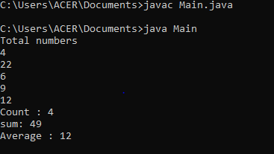s